Reši UL

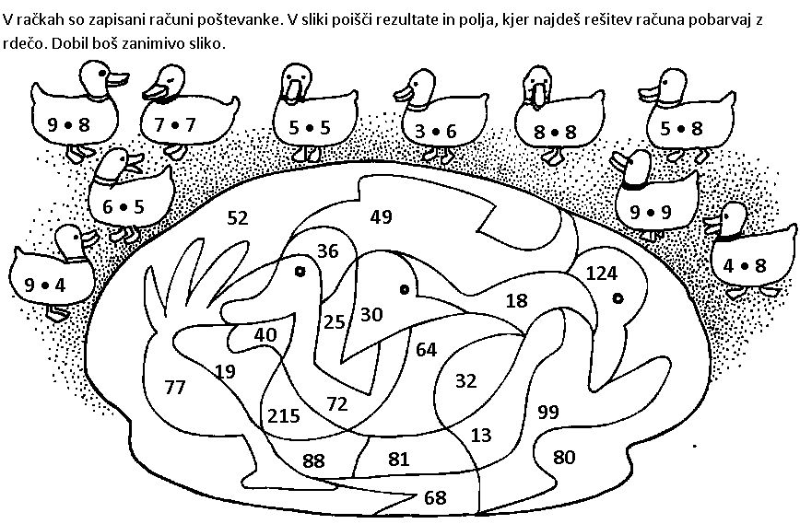

4 | 1 | 1 | ▪ | 2 |  | 1 | 2 | 1 | ▪ | 4 |  | 2 | 2 | 2 | ▪ | 2 |  | 2 | 0 | 2 | ▪ | 3
1 | 0 | 1 | ▪ | 5 |  | 1 | 3 | 3 | ▪ | 3 |  | 2 | 1 | 1 | ▪ | 2 |  | 3 | 4 | 1 | ▪ | 2
1 | 1 | ▪ | 7 |  |  | 2 | 2 | 4 | ▪ | 2 |  | 3 | 0 | 2 | ▪ | 2 |  | 4 | 4 | 3 | ▪ | 1
3 | 0 | 0 | ▪ | 3 |  | 4 | 3 | 1 | ▪ | 2 |  | 2 | 4 | 1 | ▪ | 2 |  | 3 | 1 | 2 | ▪ | 3

484  A | 34  C | 505  M | 936  E | 56  B | 682  P | 604  I | 822  R
64  L | 448  Č | 87  J | 77  O | 83  U | 443  T | 32  Ž | 482  C
58  D | 399  A | 61  P | 909  T | 365  Č | 62  L | 288  K | 862  I
900  N | 76  O | 88  E | 50  R | 55  K | 422  M | 606  I | 444  D

_ _ _ _ _ _ _ _ _ _ _ _ _ _ _ _ !

