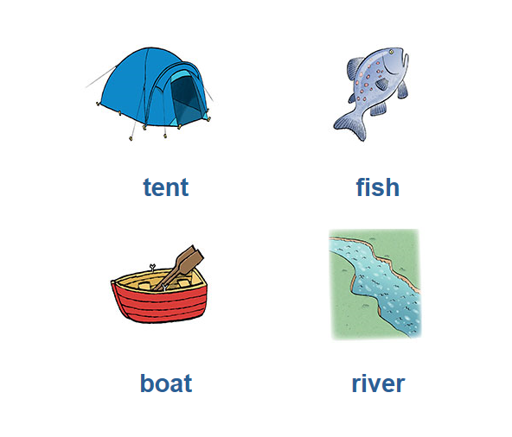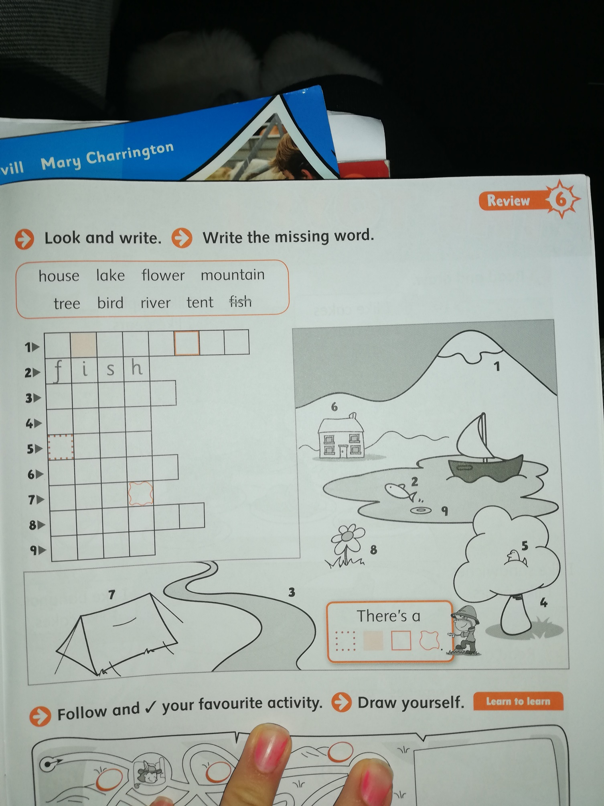

**A tent**

R _ _ _ _

B _ _ _

F _ _ _

T _ _ _