**GEOMETRIJSKA TELESA**

POIMENUJ GEOMETRIJSKA TELESA.

|  |  |
| --- | --- |
| File?id=df4r376z_5gqmxhncx_b | https://docs.google.com/File?id=df4r376z_1gv5x9qnm_b |
|  |  |
| image | https://docs.google.com/File?id=df4r376z_2gqsjnnfq_b |
|  |  |
| https://docs.google.com/File?id=df4r376z_6dwz6kcgh_b | https://docs.google.com/File?id=df4r376z_3936bhsfk_b |
|  |  |

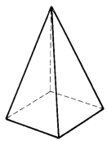

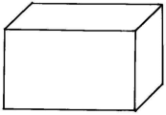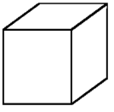

KOCKA KVADER PIRAMIDA

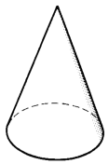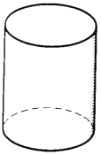

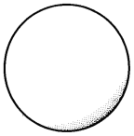

VALJ STOŽEC KROGLA